Smart Battery Analytics Engine

Elevance Internship Submission
Submitted By: Harsh Patel
Domain: Embedded Systems / AIoT
Platform: ESP32 + Wokwi + Blynk IoT

This project implements an ESP32-based intelligent battery monitoring and protection system capable of real-time voltage monitoring, fault detection, runtime state management, cloud telemetry, safety protection, and predictive analytics.

Objective
The objective of this project is to design and simulate a smart embedded battery monitoring and protection system using ESP32. The system continuously monitors battery cell voltages, detects abnormal conditions such as overvoltage, imbalance, and sensor faults, and performs intelligent decision-making to protect the battery pack.
The system also integrates cloud telemetry through Blynk IoT, allowing real-time remote monitoring and analytics visualization.

Problem Statement
Traditional battery monitoring systems often focus only on displaying raw sensor values and lack intelligent fault prediction and safety response.
This creates major challenges:
- Delayed fault detection
- Reduced battery lifespan
- Safety hazards due to overvoltage
- Poor remote monitoring
- Lack of predictive maintenance
This project addresses these challenges by combining embedded systems, analytics, and IoT-based diagnostics.

┌─────────────────────┐
│ Battery Cells (x4) │
│ (Simulated via Pots) │
└─────────────────────┘
│ ADC Readings
▼
┌─────────────────────────────┐
│ ESP32 │
│ Sensor Monitoring │
│ Fault Detection │
│ State Machine Logic │
│ Battery Analytics Engine │
└─------─────────────────────────┘
│ │ │
│ │ │
▼ ▼ ▼
┌─────────┐ ┌────────┐ ┌─────────────┐
│ Relay │ │ Buzzer │ │ I2C LCD │
│Protection│ │ Alerts │ │ Local Status│
└─────────┘ └────────┘ └─────────────┘
│
▼
┌──────────────────┐
│ Blynk Cloud │
│ Dashboard / IoT │
└──────────────────┘
Component | Purpose
ESP32 Dev Board | Main controller
Potentiometers | Simulated battery cells
16x2 I2C LCD | Local display
Relay Module | Protection cutoff
Buzzer | Audio alerts
Blynk IoT | Cloud dashboard
Wokwi Simulator | Simulation platform

System Architecture
The system architecture is centered around the ESP32 microcontroller, which acts as the main processing and decision-making unit.
Four simulated battery cells provide analog voltage inputs to the ESP32 through ADC channels. These readings are continuously processed by the embedded firmware to perform sensor monitoring, fault detection, battery analytics, and runtime state classification.
The analytics engine calculates important parameters such as average voltage, pack voltage, battery health score, failure probability, and cell imbalance. Based on these values, the state machine classifies the system into one of four runtime modes: NORMAL, DEGRADED, FAILSAFE, or SHUTDOWN.
Depending on the detected state, the ESP32 controls multiple output devices:
- Relay Module for battery/load protection and emergency cutoff
- Buzzer for audible fault alerts
- I2C LCD for local real-time status display
Simultaneously, the ESP32 transmits telemetry data via Wi-Fi to the Blynk cloud dashboard, enabling remote monitoring, diagnostics, and visualization of battery performance.

Features Implemented

Core Features
✅ 4-cell voltage monitoring
✅ Average voltage calculation
✅ Pack voltage calculation
✅ Battery health scoring
✅ Failure probability estimation

Safety Features
✅ Overvoltage detection
✅ Cell imbalance detection
✅ Sensor disconnect detection
✅ Relay protection cutoff
✅ Anti-relay chatter logic

Smart Features
✅ AI-inspired recommendation engine
✅ Runtime state machine
✅ Fault history logging
✅ Risk classification

Cloud Features
✅ Blynk dashboard integration
✅ Real-time telemetry
✅ WiFi signal monitoring

Runtime Modes

Mode | Meaning
NORMAL | Healthy system
DEGRADED | Minor fault
FAILSAFE | Critical fault
SHUTDOWN | Severe fault

Key Engineering Concepts

State Machine Architecture - Prevents spaghetti logic

Non-blocking Timing - Used millis() instead of delay

Anti-Chatter Protection - Cooldown prevents relay damage

I2C Protocol - Efficient LCD communication using 2 wires

AI-inspired Analytics - Rule-based predictive scoring

Dashboard Description

VIRTUAL PINs:

- V0–V3 → Cell voltages
- V4 → Average voltage
- V5 → Pack voltage
- V6 → Battery health
- V7 → Risk level
- V8 → Sensor status
- V9 → Relay status
- V10 → Cloud status
- V11 → AI recommendation
- V12 → Fault history
- V13 → Failure probability
- V14 → WiFi RSSI

DASHBOARD

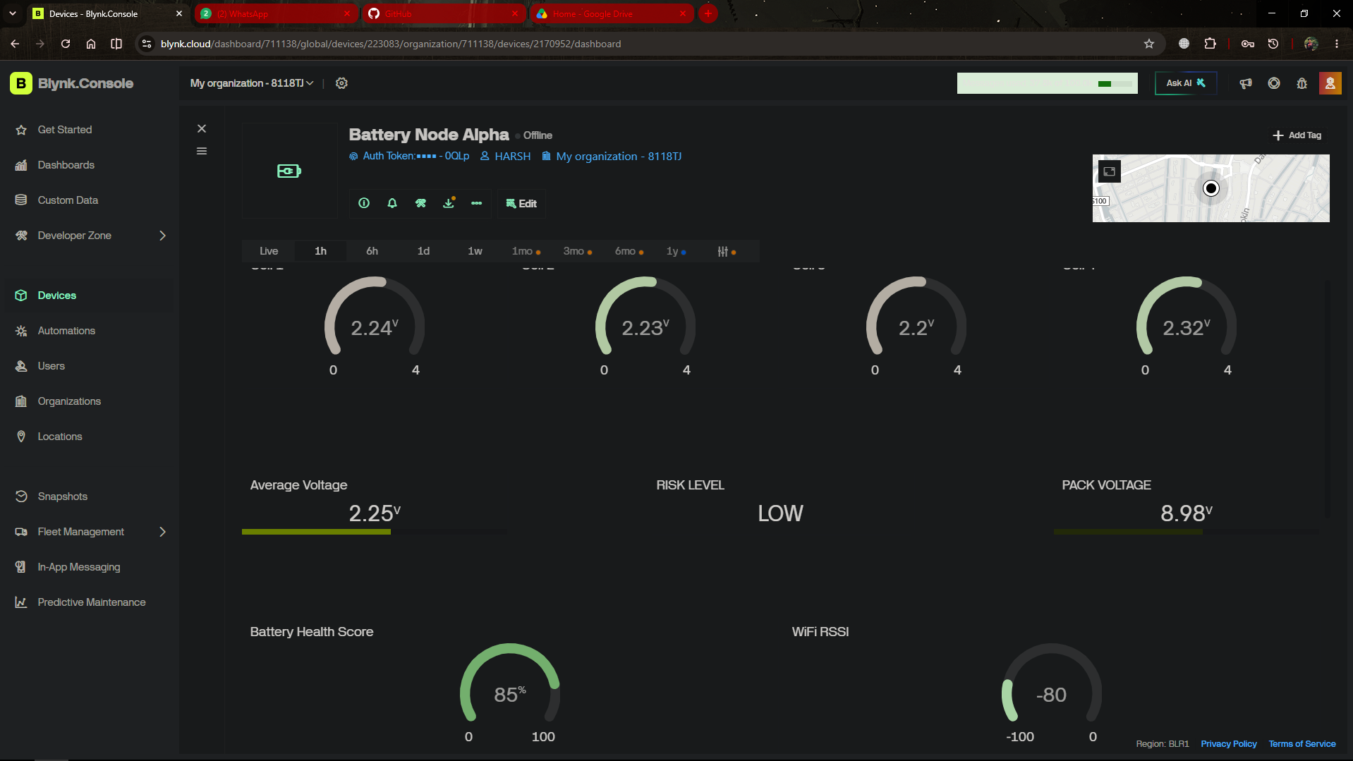

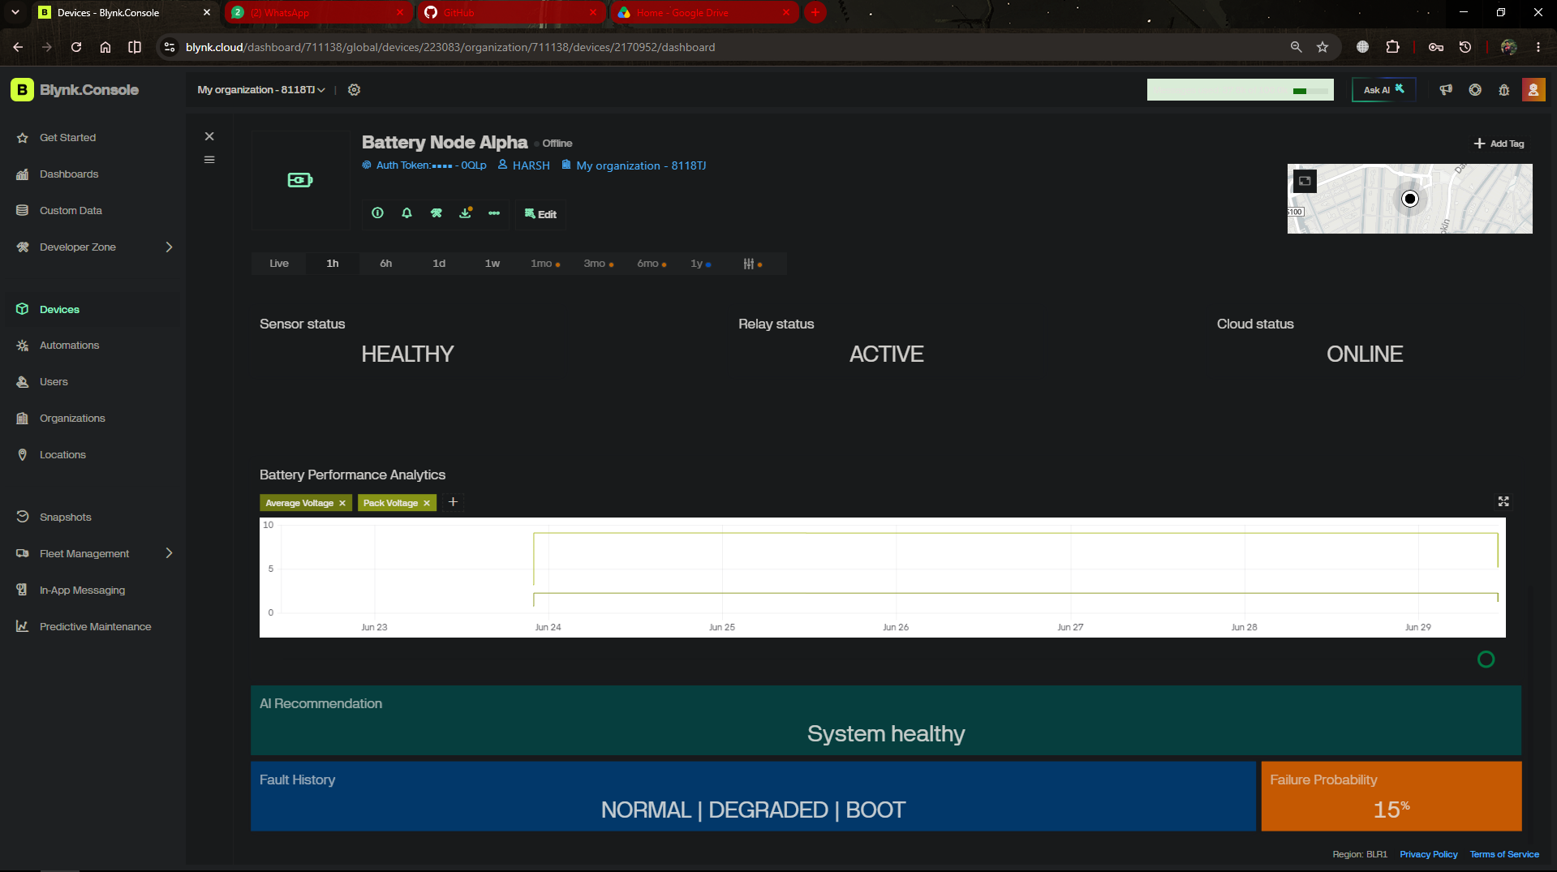

Normal mode
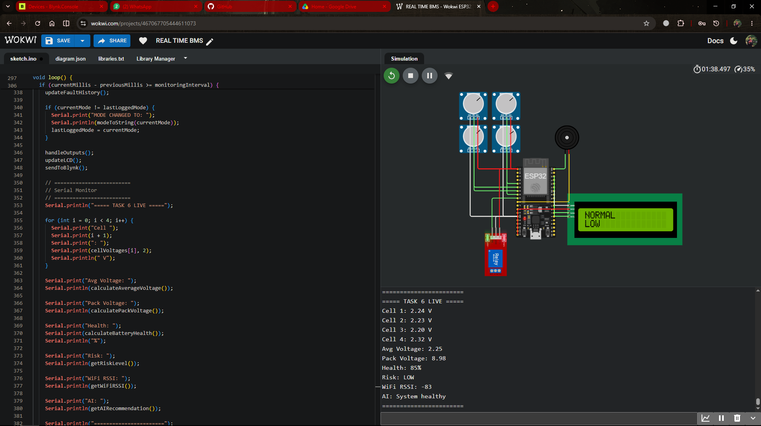

Degraded mode
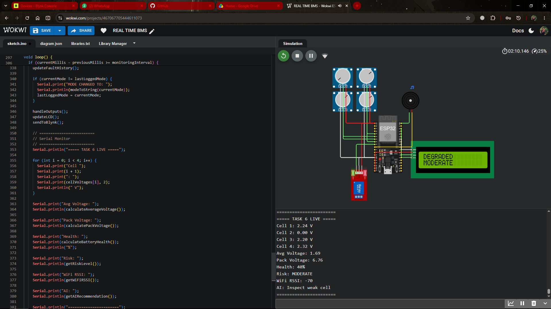

Failsafe mode
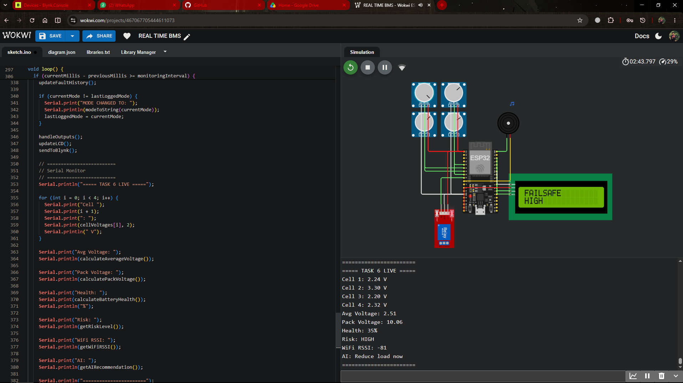

Shutdown mode
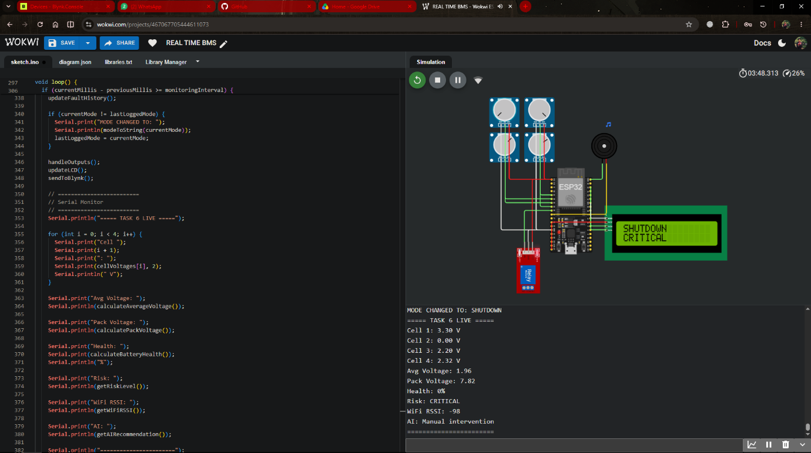

Challenges Faced
- LCD flickering
- Blynk chart issues
- relay chatter prevention
- cloud sync handling
- threshold tuning

Future improvements
- temperature sensing
- current sensing
- SOC estimation
- real machine learning models
- battery balancing
- CAN bus support
- industrial BMS scaling

Conclusion

- This project successfully demonstrates the design of an intelligent battery analytics and protection system using ESP32.

- The system combines embedded control, safety engineering, fault tolerance, cloud telemetry, and predictive analytics to create a smart monitoring solution.

- The project helped strengthen practical understanding of embedded systems architecture, communication protocols, state machines, and real-time diagnostics.
This task represents a complete integration of embedded firmware, IoT, and intelligent decision-making.

